Description of the basic idea

Introduction
The aim of this document is to describe a way to optimize the development of a compiler for implementing a data base(see below).

Illustration 1: Basics with the SHELL

Description of dictionaries

- Description of the syntax
We define a set of rules that define a syntax.
The definition of the syntax is not yet defined see later.

- Description of the grammar
We define a set of rules that define the grammar.

- Description of the words
We define a dictionary that define the root words that can be used. The notion of a word is not yet defined.

The architecture description
Architecture the basic compiler is composed of file descriptors. That file descriptors can be seen as a dictionary that will be read and analyzed by the compiler.

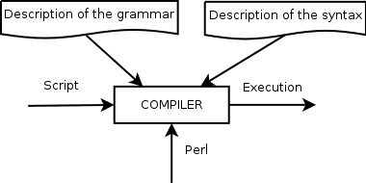Illustration 2: Architecture of the basics
This will avoid to rewrite the rules of the compiler each time.
We need to define what are the basics to be coded. Need to defines the verbs, actions,...
This syntax then will refer to a file that contains the set of words. All together it will define a language.

Structures of the dictionaries
The structure is not yet defined but the format will probably be XML.

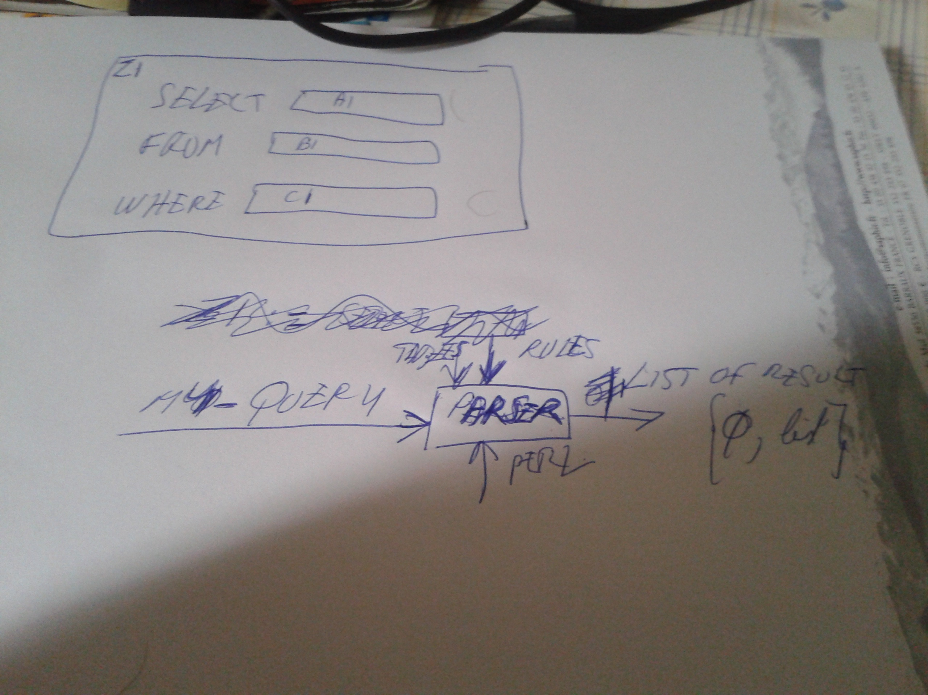Illustration 3: Basic information related to the file that defines structures
Now here we have the file that do the definition.

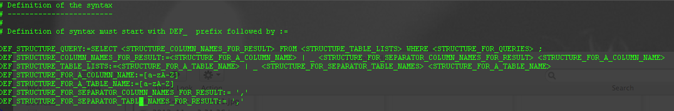Illustration 4: Basic definition of a syntax structure of a query no queries defined yet

From this file a parser need to be constructed. This is only a sample. Definitions need to be optimised.

Definition of the features of this parser
To parse this file, to analyze it, to check it a Perl script will be built. It will check any errors in the syntax, if no errors are found then it will store all the syntax information in the memories. Then it will be used to parse the query defined by the user. Its kinda compiler see schema below.

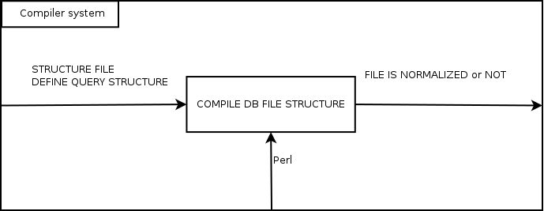Illustration 5: Basic description of the system that analyze file that describeData Base query syntax structures

Basic mechanism
We do macro compilation. Go to the leaf definition. We replace to the definition into the father definition. Then do the replacement to the father of the father and so on and so fourth.
At the end we must have the first definition in the file that will be replace by its basic definition. Then this can be match with the final definition(the user one). The recursive definition will shows up as _ in the root definition (to redefine not well formulated) but in the final version this will be removed. In the definition of the format of the query only the syntax in the definition will be check, syntax too:

DEFINITION_NAME <def> ROOT
DEFINITION_NAME1 <def> NAME
DEFINITION_NAME2 <def> NAME NAME1
DEFINITION_NAME2 <def> NAME _
Example of file that define the format of a query
will be digested by the compiler with OR but not the operator

instead of the next definition which is much more concise:

DEFINITION_NAME <def> ROOT
DEFINITION_NAME1 <def> NAME
DEFINITION_NAME2 <def> NAME NAME1
| NAME _
Example of file that define the format of a query
will be digested by the compiler with OR operator '|' used

Recursivity will be defined with the _ operator. We can suppose or guess that in the final version of this script this will be optimized. No cardinality is defined yet.

The OR operator is not yet defined. A good guess will be enumeration within the file (not good solution).
We only have to check the syntax. The syntax then will define the format of the query. This is where we will compare the user definition with the syntax of the given query. To group elements parenthesis can be used. It is not defined yet.

Security
Dictionaries can be encrypted. Algorithm not defined yet.

